Final Project Overview

When a marching band student is learning their show for the upcoming season, it can be a long and tedious experience. They are generally given a set of drill charts, which can look something like this:

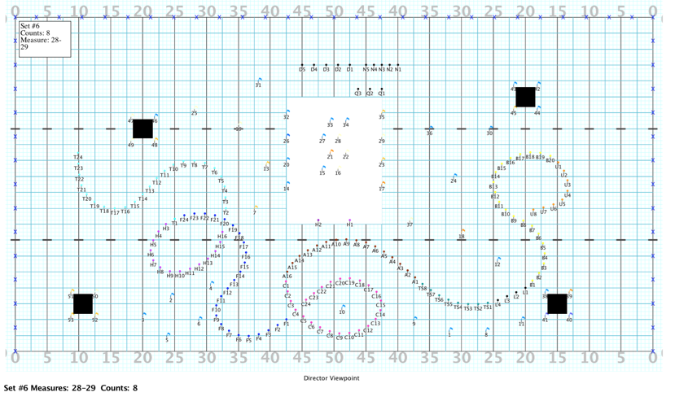

There is a lot of information here. Each “dot” you see is an individual member. And there can be over 100 of these sets in a show. Each student is then required to copy each coordinate from all these sets into what is known as a dot book. These books can be flimsy and easily destroyed by weather or sweat.

My idea is to create a website that will allow students to login and enter their set information and store it in a database with the rest of the students from that program. It would then allow them to have their “dot book” in a digital format such as a smartphone. This would allow for it to of course be more sturdy but also easily adaptable should any changes in the design occur.

There are services that perform this function already, sort of. Mostly these services allow you to submit the drill file that the designer provides and in turn then send you a pre-printed book with all the sets in it. This completely removes the responsibility of the member of learning their sets and instead hands them a completed book on day one. My version would keep that responsibility intact and as an added benefit, demonstrates the value of teamwork since you will not see the entire set unless everyone participates.

Future development would include adding the ability to print out the books on a home printer, removing the need to pay for expensive printing via one of the existing services.

I would also like to add a more social network type section where members of each school can communicate and perhaps directors can use it to get information out to the students as well.

Monetization can occur once the site reaches a viable point to do so, by charging each school/independent group a small per-member charge per year. In Orange County alone there are around 19 high schools and with at least 100 members per group, that could be a pretty good way to make some money.